ON-LINE CATALOG PIN REGISTRATION INSTRUCTIONS

- Each library card holder , DA Civilian, DoD employee, Contractor, Sponsor and family members, need to have their own e-mail address entered into the database when registering for a library account. The same person cannot access MyAccount on the library’s On-line catalog with the same e-mail address.

- Once you have registered for a library card with an e-mail address. Go to the Library Online Catalog and click on “MyAccount”

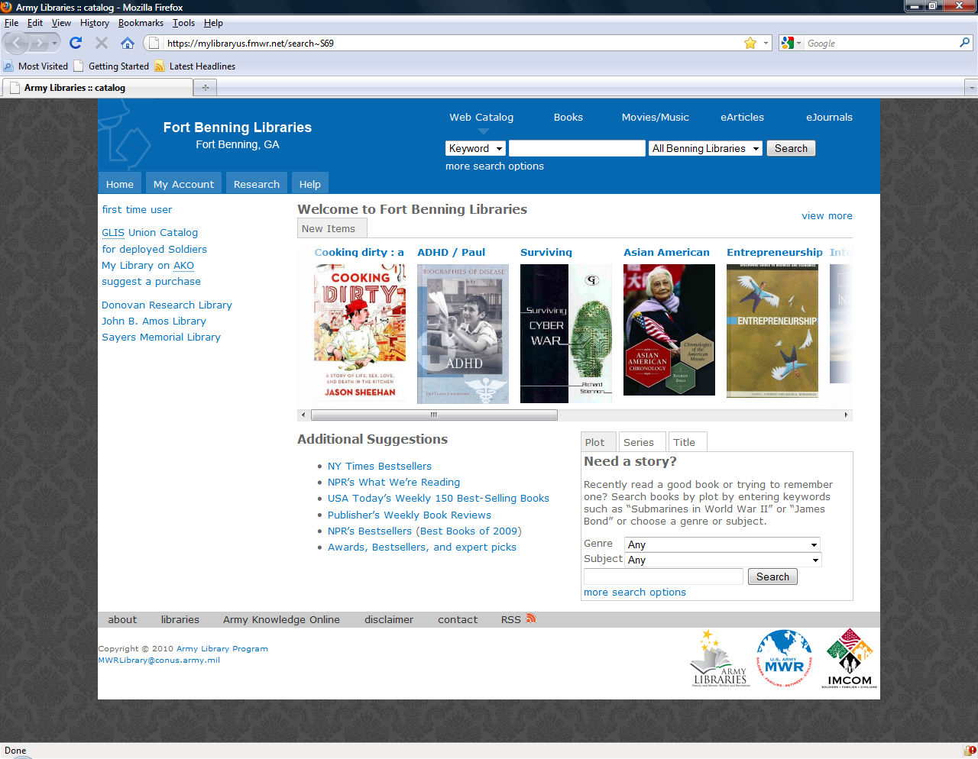

- Enter e-mail address in the Web Login box. Patrons can also refer to the “First-time Users” link for instructions.

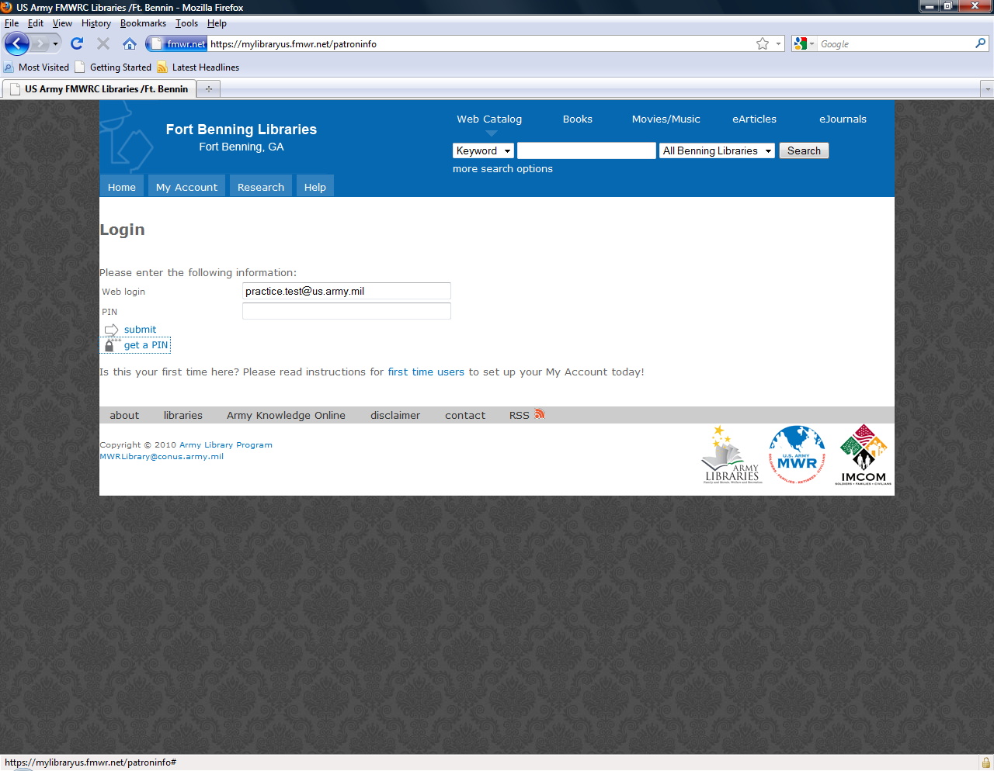
- Enter your e-mail address again into Web login box below . Click “Get a PIN”. A link for your PIN Request will be sent to you r e-mail address on record.
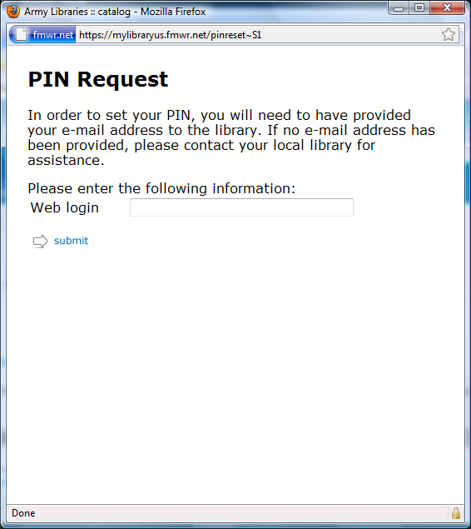

- Click on the link in your e-mail to reset your PIN. The link to reset your PIN is only good for three hours so make sure you click on the link and change it immediately. Type in a new PIN and click on “SUBMIT”.
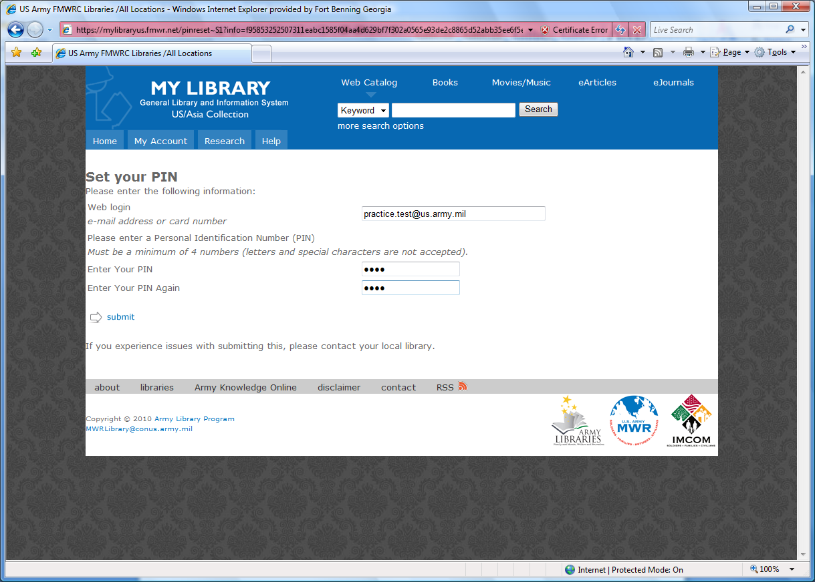

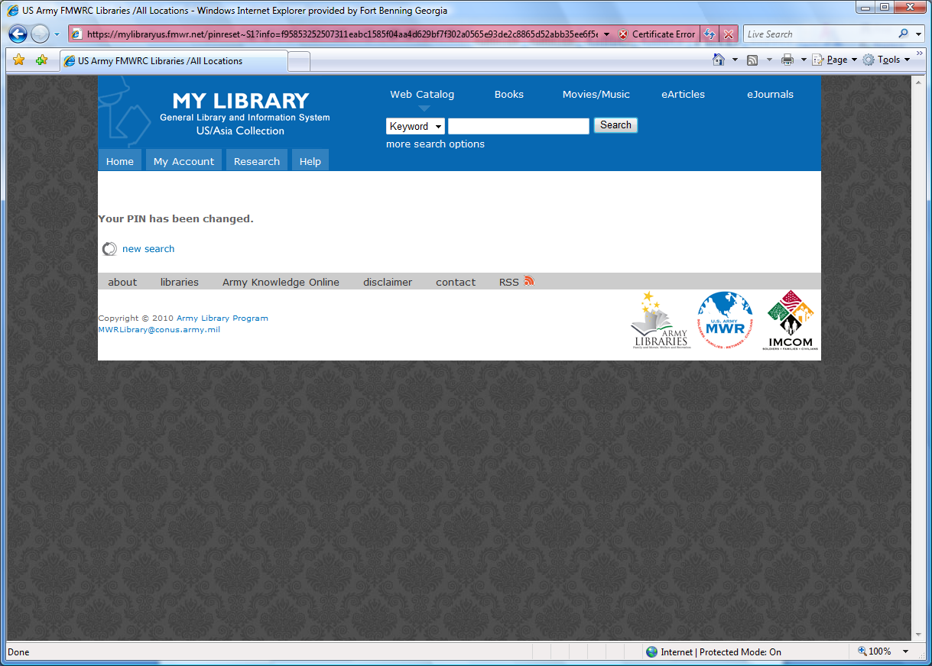

- Click on “MyAccount”, enter username and new PIN to access account information. Once entered you can also click on “Research” to access the databases for further research.

